**X-Ray Image Matching:**

**ASD Progress Report**

May 2015

Our work has been mainly to develop a program in python which can more actively clean the x-ray images to be ported to the existing program written previously. The current operation is still a working progress.

1. Background

The Berkeley Engineering Initiative group goal is to match spinal x-rays. The current x-ray images look like:

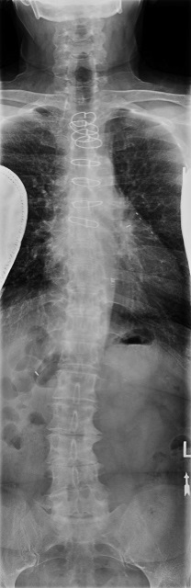

Note that there are many other features that obstruct the view of the spinal cord. Our goal is to find a way to remove some of the noise that are generated from the x-ray images to get a better sense of where the spinal cords are.

1. Current Progress:

I am working on developing a python program which can more actively clean the images. This is the current result:

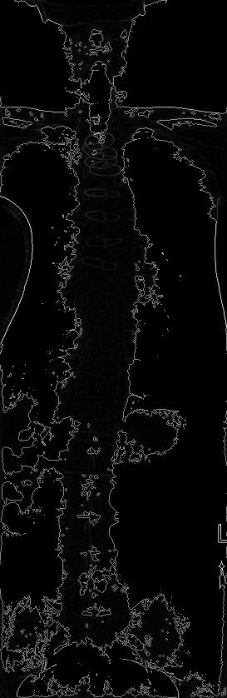

The current program currently cleans the image by determining the gradient difference between each pixel. It essentially replaces each pixel with the max gradient difference between its surrounding pixels. This accentuates the locations where there is a clear difference between the spinal cord/bone and the surrounding noise.

A more detailed algorithm is displayed below:

1. Remove pixels that have a lower intensity value than 125

It is removing some of the tissues. Note that max gradient difference makes noise/tissue seem more important than before since these tissues usually don’t have pixels surrounding them.

1. Run the gradient difference algorithm on cleaned image
2. Rescale the intensity of the new image

Returning the max of the gradient difference decreases the intensity value of the image. The goal is to make the images clearer by rescaling the image intensity for better visibility

1. Future iterations:

My previous program has a lot of noise, mainly in three different aspects:

1. It does not remove any of the bone structure; in fact, it makes them stronger. This means that the program is unable to isolate the spine from the rest of the bone structure.
2. There are some tissues that still exist in the image (note the lump on the side of the spine near the middle). These tissues are emphasized because they have a higher intensity value than 125; however, its surrounding pixels have 0 because of the pixel removal. This causes the tissues to have a bigger impact on the spinal structure than before.
3. The program is extremely slow because it is comparing each pixel. My program runtime is O(xy+5xy+xy) =O(7xy) where x is the row and y is the column.

We are currently working on a way to fix the second and the third problem right now. We are implementing a new low intensity cleaning algorithm. Instead of just removing a low intensity pixel, we are also looking at its surrounding pixels and removing pixels that are too similar to that pixel. This will hopefully remove some of the extra emphasis that these tissues have. The current output is:

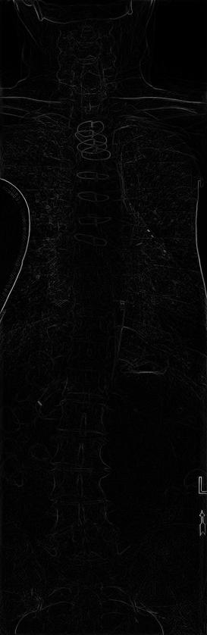

Note that it removes a lot of the tissues near the bottom; however, the spinal structure near the top seems to be completely removed. This means that the values are probably not right and so the function needs tuning. It is also extremely slow (around 1-2 hours to generate this image).

We are also going to implement threading to speed up the image processing ability.

1. Conclusions:

It is still a working progress. We hope to continue to keep up this progress in the future. Thank you for the opportunity.